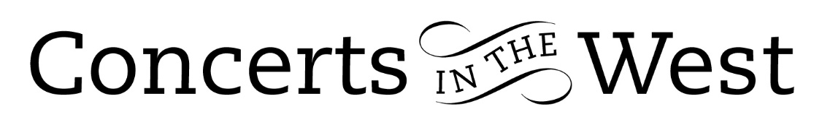
LARA MELDA
21-22 June 2024
Bridport Arts Centre, Ilminster Arts Centre, The Dance House Crewkerne

Lara Melda has a deserved reputation as a pianist and many in the audiences of this latest ‘mini-tour’ organised by Concerts in the West were there because of the esteem in which she is now held. Lara who began learning the piano at the age of six broke into the consciousness of the music public when she was the outright winner of the BBC Young Musician Competition in 2010. Since then, Lara has developed her career and reputation as a concerto and purely solo pianist here in the UK, Europe and in particular the country of her parent’s birth, Turkey. In 2016 Lara Melda graduated with a First Class Degree from the Royal College of Music. She has worked closely with Alfred Brendel and released her first CD in 2020 with solo piano pieces by Frédéric Chopin.

Lara brought to the three Concerts in the West venues a programme of sonatas and other pieces by Liszt, Chopin and Beethoven. The monumental Liszt B minor Sonata was preceded by the beautifully lyrical Chopin Nocturne B flat minor Op 9. Through this piece Lara lulled us into a haven of calm and tranquillity before casting off and taking us on a journey of compositional drama full of technical demands and emotional challenges for a full 30 minutes. To demand of herself such a journey at the end of a programme preceded by Chopin’s exacting Sonata No. 3, also in B minor, and Liszt’s ‘Un Sospiro’ Étude might seem to be a physical ‘Bridge too far’. But Lara obviously warms to the idea of a confrontation with nature and stamina and proved to be more than a match to the task!

The Yamaha pianos (Crewkerne and Bridport) seem to be more at home with the music-drama and the faster finger-work sections of Liszt while the Kawai at Ilminster offered a better response with its generally warmer tone in the ‘song-like’ passages of both composers.

The Scherzo movement of the Chopin Sonata were deftly handled while the need for serenity and nuanced phrasing and dynamics in the Largo was supremely sensitive. Tempo variation and control of dynamic surges was excellent in the Finale movement. However, it was Lara Melda’s response to the technical and emotional demands of Liszt’s gigantic musical landscape with its modernistic structural elements and intense Wagnerian-like drama that brought about a sincere, warm, and enthusiastic response from the audience for Lara Melda. The encore reward was the very apt Allegretto movement from Beethoven’s so-called ‘Tempest’ Sonata.

Andrew Maddocks 2024

